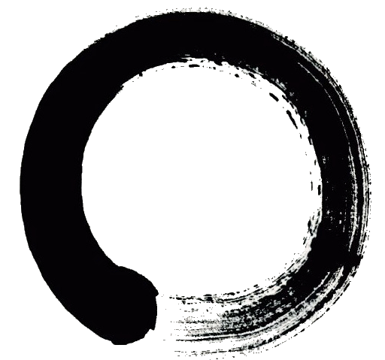
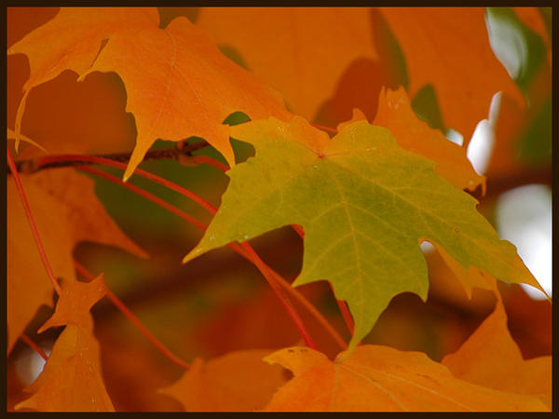
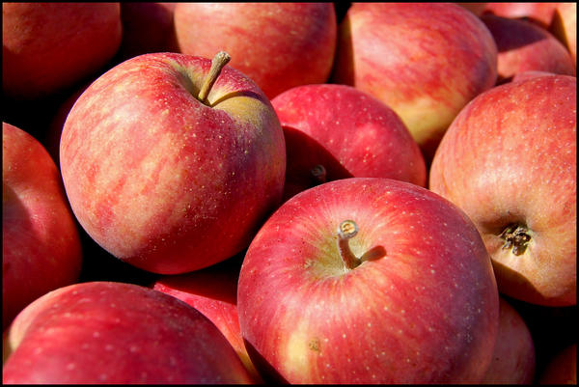
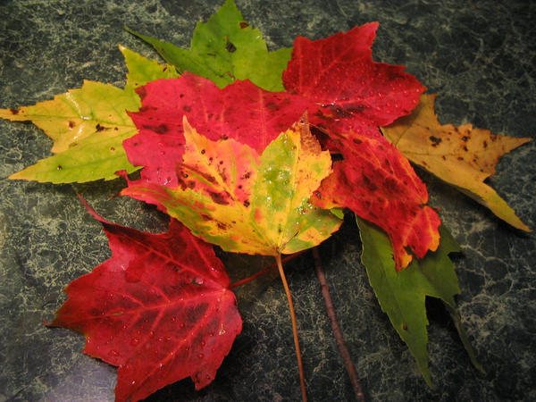
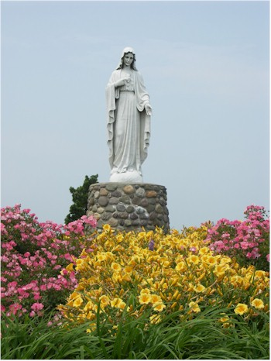
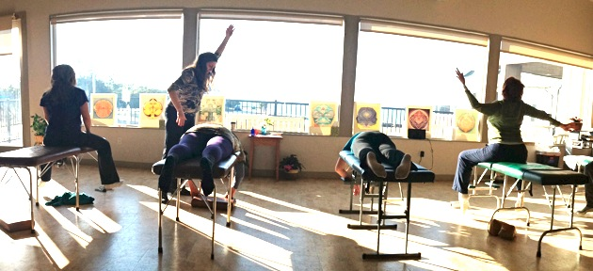
  - “What we plant in the soil of contemplation, we shall reap in the harvest of action.”
- Meister Eckhart
Halloween
The Halloween Parade will be Saturday October 26th this year, and Trick-or-Treat will be Thursday October 31st.
Transform Workshop
October 26th at the Maris Stella Retreat Center in LBI. See page 2 for more info.
Clear Day!
Downtown Toms River will hold their annual Harvest Festival on Saturday October 19th.
Harvest Festival
The next SRI Workshop will be November 13th.

The Sound of One Hand Clapping
The sound of one hand clapping is the sound of the Big Bang. It is the sound of supernovas exploding, of atoms colliding, of birds singing, and of the clink of dishes in the sink. It is the One sound that imparts form on the entire manifest universe, and you are that sound.

The nervous system organizes the internal and external waves of this sound as they shape and direct the experiences of life. The symphony of sounds with which we identify are ultimately the facets of the diamond of the One sound.

The basic principle of Chiropractic is Tone. Transcending and including the tradition of Chiropractic, Network Spinal Analysis brings deeper awareness to the body and empowers you to connect, transform, and awaken to your life, using the spine as the vehicle for change. It does not give you anything or take anything away. It simply helps you to rediscover what you have always heard and what you already hear - who you really are, the One sound.

Upcoming Events
October 2013

Waves of Transformation Wellness Center, Inc.
+

+
At the

Maris Stella Retreat Center

Long Beach Island, NJ

October 26, 2013

8 AM – 6 PM

The Clear Day
During the Harvest we reap the seeds that were sown in the time of planting. Autumn is a time of transition. The air becomes crisp, the days begin to shorten, and we must figuratively and literally take stock of what we have and where we are in order to prepare for the winter.

The Clear Day is an event designed to bring more Grace to the process of transition, both seasonally and personally. It is a day spent in community. It is an opportunity to reorganize what you have been cultivating and to prepare for the next stage and season.

There will be 3 entrainment sessions and 2 workshops over the course of the day. We encourage everyone to bring a dish to share for a community lunch.

Deepening the work we do in the office, the Clear Day is ultimately about helping you to Discover where you are, Transform to what you need to be, and to Awaken to who you truly are.

We look forward to seeing you there.
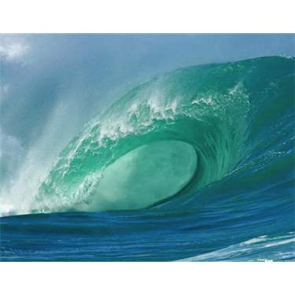
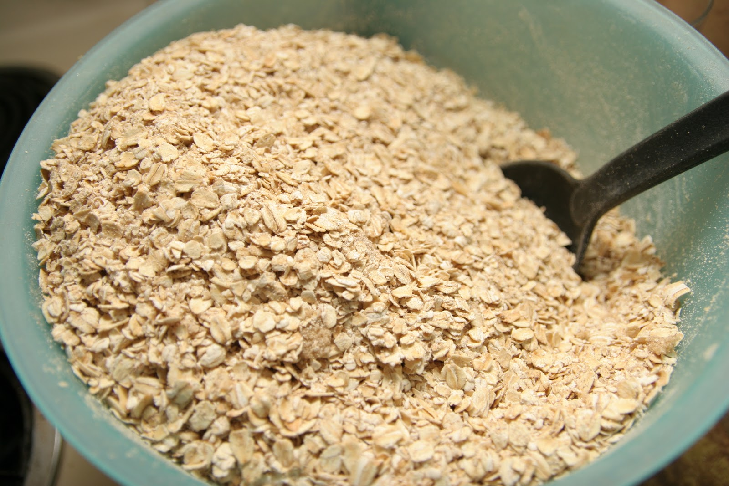
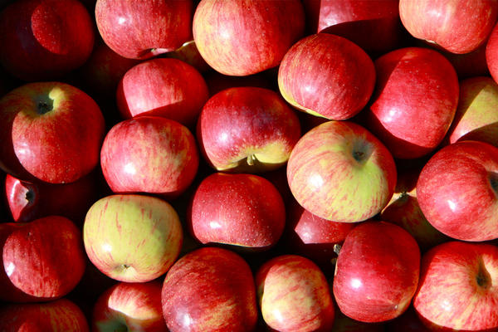
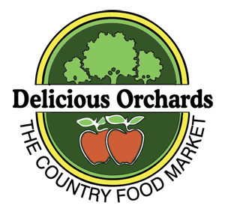

Did you know?
Apple Cider is the official state beverage of New Hampshire.
Waves of Transformation Wellness Center, Inc.

Dr. Donna M. Mutter, DC
Dr. Daniel Eric Mutter, DC

309 Main Street
Toms River, NJ
08753

732 244 5008

wavesoftransformation.com
njwavesoftransformation@gmail.com
Recipe courtesy of Delicious Orchards, The Country Food Market in Colts Neck, NJ.
You’ll need:

1 cup Apple Cider
½ cup Water
½ cup Steel Cut Irish Oatmeal
2 tablespoons Nuts (pecans, walnuts, etc.)

Directions:

- Bring Apple Cider and water to a boil in a small heavy saucepan.
- Add oatmeal, reduce to low heat, and simmer until oatmeal is cooked.
- Remove from heat and allow to stand for 2 minutes.
- Serve in a bowl, add nuts, garnish with fruit if you like, and enjoy!
Serves 2.

Apple Cider Oatmeal
October 2013
Waves of Transformation Wellness Center, Inc.

